Unit Root Test
To test for unit root stationary, primarily, the Augmented Dickey-Fuller (ADF) test was used. The ADF test checks for the presence of unit root in the time series. The hypothesis tests are summarized as follows:

Ho: yt ~ I(1), series contains a unit root
Ha: yt ~ I(0), series is stationary
where ε_{t} ~ i.i.d

The ADF test was implemented using adf.test within R (using the package “tseries”). To choose the lag input, the order obtained through an AIC vs. BIC calculation was used; subsequently, the lowest lag order was chosen.

Additionally, the Phillips-Perron test was added, using pp.test within R, to substantiate test results from the ADF test. The hypotheses are the same as those from the ADF test. Results of these tests are shown in Table 1. As shown, the p-values all show the rejection of the H_{o} for the presence of a unit root; thus, these states were determined to be stationary.

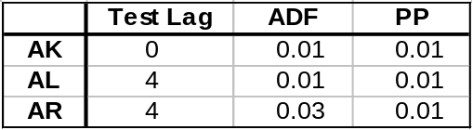
Table 1: p-values obtained from applying the Augmented Dickey-Fuller and Phillips-Perron tests to a sample of states

GPH Simulation Exercise
Fractionally integrated processes of sample sizes 1000 were generated using fracdiff.sim (R package “fracdiff”) from the ARIMA(0,d,0) distribution. The 2.5%, 50%, and 97.5% quantiles for the d values are indicated in Table 2. The GPH estimator (R package “fracdiff”) was used to estimate the fractionally integrated parameter d from the simulated data. Simulations of 1000 were used to construct the empirical quantiles, with the purpose of understanding the accuracy of the GPH estimator.

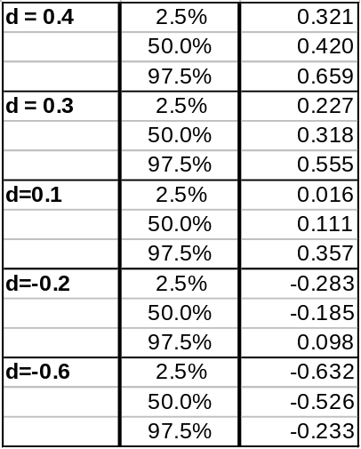
Table 2: Quantiles of d-parameter of simulated fractionally integrated processes, determined though the GPH estimator
(n=1,000; Burn-In = 1,000; Simulations = 1,000; ARIMA(0,d,0))

Selected Density Plots:
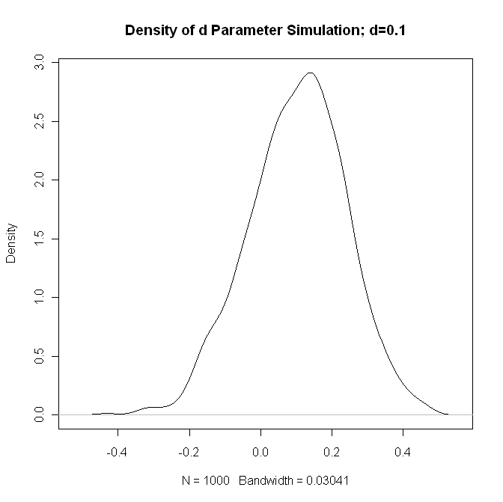
Figure 1: Density of GPH estimates of d Parameter, Simulated data has d=0.1

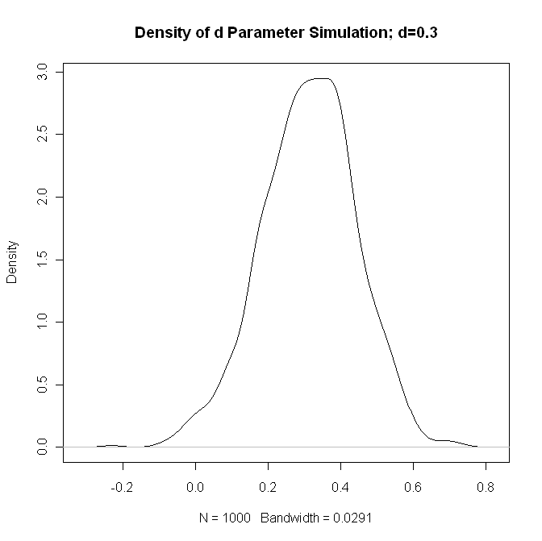
Figure 2: Density of GPH estimates of d Parameter, Simulated data has d=0.3

The density plot indicates that the GPH estimator appears to be a reasonable estimate of the fractionally integrated parameter. This is verified by the relatively light tails of the plots. The accuracy of the GPH estimator will be investigated further by comparing fractionally integrated parameter estimates to the results from other estimators.

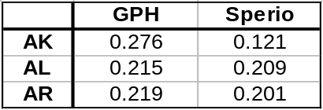
Table 3: d-parameter estimates using the GPH and Sperio estimates for a select sample of states

Using the GPH estimator as described above, d-parameters were estimated for the selected states. The results are shown above in Table 3. Additionally, d-parameters were estimated using the Sperio estimator, to gauge the accuracy of GPH. Results using the Sperio estimator confirmed the d estimates for Alabama and Arkansas. However, the results for Alaska verified the need for further investigation.

Normality Test Accuracy

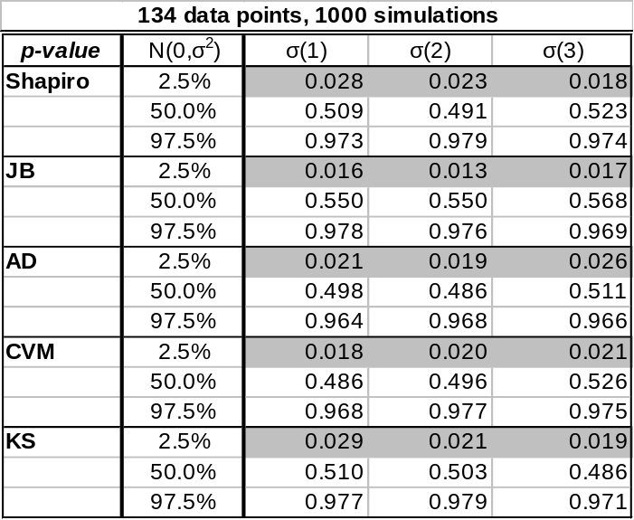
Table 3: Normality test p-values for simulated data, 134 data points

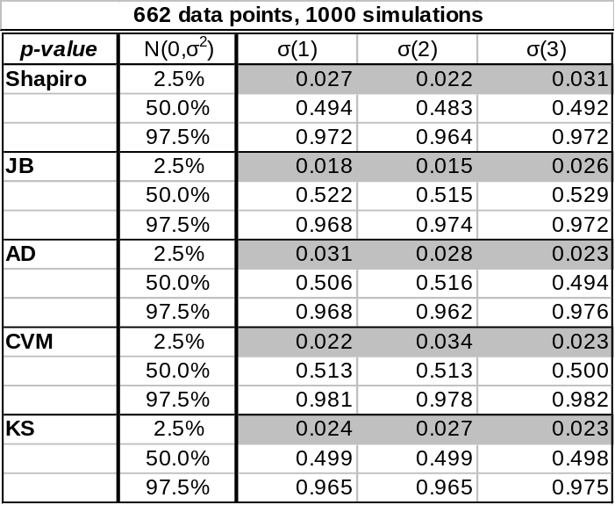
Table 4: Normality test p-values for simulated data, 662 data points

Data was simulated from a normal distribution, of both samples sizes 134 and 662, in Table 2 and 3, respectively. Normality tests were applied to the simulated data and the p-values were recorded. The simulation was repeated 1,000 times and the empirical quantiles of the p-values were recorded.

The purpose of this exercise is to determine the accuracy of the normality tests. The results were expected, with an approximately uniform distribution of p-values. This will be investigated further before conclusions are drawn.

